Insert the Title of your Presentation Here. Do not use UPPERCASE WRITING!
Firstname Lastname, Firstname2 Lastname2 (repeat for every author) – no academic titles and no numbers in this line!
(Academic Title Firstname Lastname, Institution of Author 1, Address, e-mail)
(Academic Title Firstname Lastname2, Institution of Author 2, Address, e-mail)
(separate by SHIFT+ENTER and repeat for every author)
DOI: [LEAVE THIS LINE AS IT IS AND DO NOT CHANGE IT]

Abstract
Read the text below as it contains all necessary instructions on how to format your paper properly!
Select the template „Text Standard“ for normal text paragraphs. After a paragraph, press the Enter key one time. Do not set two line breaks after a paragraph, and do not set two line breaks at the end of a chapter. You can also use bold or italic emphasis. If you do not stick to this template, bold and italic accentuation will definitely get lost during repair work done by the CORP team.
Please do not use coloured fonts.
Be careful with copy and paste commands as you will most probably insert wrong paragraph templates from the other document into this document. Better use Edit/Paste Special…, then select “Unformatted Text”. After that, format your text using the paragraph templates you can find in this document. Remember: Do not use any other formats from other documents because these will affect the formats of this template and result in a not properly formatted paper.
The maximum page size of your paper is 6 pages in the given template including all images, tables, and references. Longer papers will be rejected. Annexes are not allowed. Acknowledgements may be added between the last chapter of your paper and the references.
The first chapter of your paper needs to be named “Abstract”. Turn on the hidden formatting characters, otherwise you will not be able to follow what you are actually doing. To activate the hidden formatting characters, press the formatting characters button from the “Start” menu of Microsoft Word (top right button looking like a reverse “P” in the image below).
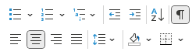
Fig. 1.: Screenshot from Microsoft Word
And here goes the blind text: Lorem ipsum dolor sit amet, consectetur adipiscing elit. In vel molestie eros. Donec tortor diam, luctus in vehicula non, volutpat ut lorem. Pellentesque eget erat odio, et lacinia odio. Curabitur in metus quis lorem placerat dictum eu at elit. Vestibulum id urna libero, luctus posuere elit. Donec vitae urna est. Quisque euismod feugiat pharetra. Phasellus dolor ligula, cursus eget auctor quis, molestie sed felis. Aliquam erat volutpat. Morbi orci nunc, faucibus non facilisis et, gravida id libero. Fusce vitae justo mi. Sed scelerisque ipsum non sem aliquet egestas faucibus libero pulvinar.

Header 1

Header 2
Praesent sed turpis nibh. Maecenas ut leo a ipsum varius porttitor. Pellentesque ultricies lacus ac ipsum molestie sagittis. Class aptent taciti sociosqu ad convallis, arcu mi tempus quam, sit amet cursus magna nibh et risus. Praesent at nulla metus. Integer neque purus, varius id convallis at, aliquet non elit. In nisl est, condimentum nec pharetra quis, gravida quis mi. Suspendisse adipiscing placerat eros, nec hendrerit metus sagittis non. Nulla id turpis vel leo cursus vulputate. Pellentesque habitant morbi tristique senectus et netus et malesuada fames ac turpis egestas.

Header 2
Donec leo nunc, cursus ac congue quis, rutrum sed quam. Vivamus viverra rutrum quam vel porttitor. Nullam ultrices augue quis justo semper luctus. Praesent gravida bibendum enim, accumsan mattis nunc tempus nec. Fusce consequat malesuada urna in euismod. In facilisis nibh iaculis sem condimentum dictum. Pellentesque sit amet sem nisi, eget pellentesque felis. Donec nunc sapien, suscipit vel auctor ut, accumsan vitae magna. Nullam in mauris elit, at tempor erat.

Header 3
Suspendisse vestibulum, ante a tincidunt ultricies, orci sapien tristique mauris, et fringilla lorem ante nec leo. Cras massa urna, sagittis accumsan pellentesque eu, consectetur id velit. Nullam lectus neque, sodales nec adipiscing ullamcorper, sodales non odio. Quisque sapien mi, congue quis gravida id, aliquet id leo. Nulla facilisi. Praesent mattis turpis ut lorem vehicula non blandit elit posuere. Cras vel mi dui, malesuada accumsan quam. Lorem ipsum dolor sit amet, consectetur adipiscing elit. Aliquam erat volutpat. Morbi orci sem, fringilla et accumsan vitae, porta quis odio.

Header 3
Vestibulum quis nibh mauris, commodo venenatis lectus. Cras elementum sem a dui adipiscing eget gravida mauris eleifend. Duis vitae felis id metus mollis faucibus. Morbi erat nisl, laoreet eu tempor in, hendrerit placerat augue. Morbi urna magna, volutpat in ornare et, rutrum vel ligula. Nullam tristique odio nec neque pulvinar at lobortis mauris laoreet. Curabitur at vehicula ipsum. Nulla euismod quam a urna dapibus interdum. Sed vestibulum, neque nec convallis viverra, enim arcu consequat ante, id lobortis nunc felis id turpis. Cras aliquam posuere leo, ac convallis sem vulputate nec. Aliquam libero massa, cursus id mollis nec, consectetur ac eros.
Header 4? No, there is no header 4. Your header structure must le limited to three levels, which is sufficient for a maximum paper length of 6 pages for a non-reviewed paper.

Header 1
Vivamus in leo velit, vitae tristique elit. Vestibulum lectus sapien, semper id convallis in, sollicitudin ut nisl. Nunc eget, orci turpis rutrum ante, vitae scelerisque purus nunc eu ipsum. Nulla facilisi. Maecenas quis ipsum eget eros rhoncus dapibus in dictum tortor. Vivamus porta nisi vel est varius iaculis. Sed quis tortor odio, quis adipiscing ligula.
If you insert an image, place it right in-text, not behind or in front. Select the template “CORP Beschriftung” for both the image itself and the caption which must be placed below the image and not above. Do not place images in tables or text areas. The same applies to image captions.
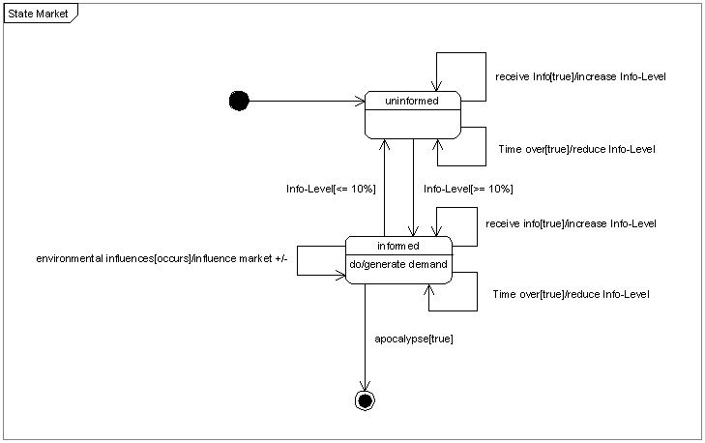
Fig. 2: Title of Figure 2. Please do not use automatic numbering of figures and tables.
Mauris faucibus adipiscing placerat. Suspendisse potenti. Aliquam erat volutpat. Praesent interdum varius dolor a laoreet. Donec adipiscing neque consectetur purus accumsan mollis. Phasellus dictum porttitor erat. Vestibulum eleifend vehicula nunc, non semper est condimentum sit amet. Aliquam faucibus diam a dui sodales et pellentesque nisl mollis. Suspendisse mollis ullamcorper imperdiet. Etiam sed odio quam. Integer justo velit, vestibulum ac volutpat nec, elementum ut metus. Suspendisse varius elit ac orci ornare facilisis.
A table with template “Tabelle 10 pt”.
Table 1: Use “CORP Beschriftung” for table captions and place them below the table. Please do not use automatic numbering of figures and tables.
A table with template “Tabelle kleiner”.
Table 2: The template “Tabelle kleiner” is meant for bigger tables to make them fit the page.

Conclusion
If you do not stick closely to this template, the REAL CORP team will have to re-work your paper. This means that ALL special formats, like bold text, italic text or underlined text will definitely get lost.

References
YOUR, References: Must be set in template “Literaturverzeichnis”. Vienna, 2011.
AUTHOR, Author: Title of the source. Vienna, 2009.
BUTHOR, Author: Title of the source. Vienna, 2009.
CUTHOR, Author: Title of the article. In: Title of the Periodical, Vol. 47, Issue 5, pp. 123-456. Vienna, 2009.
DUTHOR, Author: Title of the article. In: Title of the Periodical, Vol. 47, Issue 5, pp. 123-456. Vienna, 2009.

An example for a footnote. Do not make excessive use of footnotes!

